**PROJECT 1: PRELIMINARY ANALYSIS**

1. The target user for my project is one of my close friend, who is currently looking for different classes and majors on campus. I suggested him to use a web site that I am using to learn web engineering.
2. I am using an interface- website that is supposed to have enough information to become a full-stack web developer. It has some links that lead to a website like w3school that is very good at learning the things to master the web. It also has assignments that we can follow and progress ourselves. In general, it’s a web-learning website of one of the faculties in BYUI campus. But at the end of the semester, I am thinking of designing my own website that will teach people to master the web.

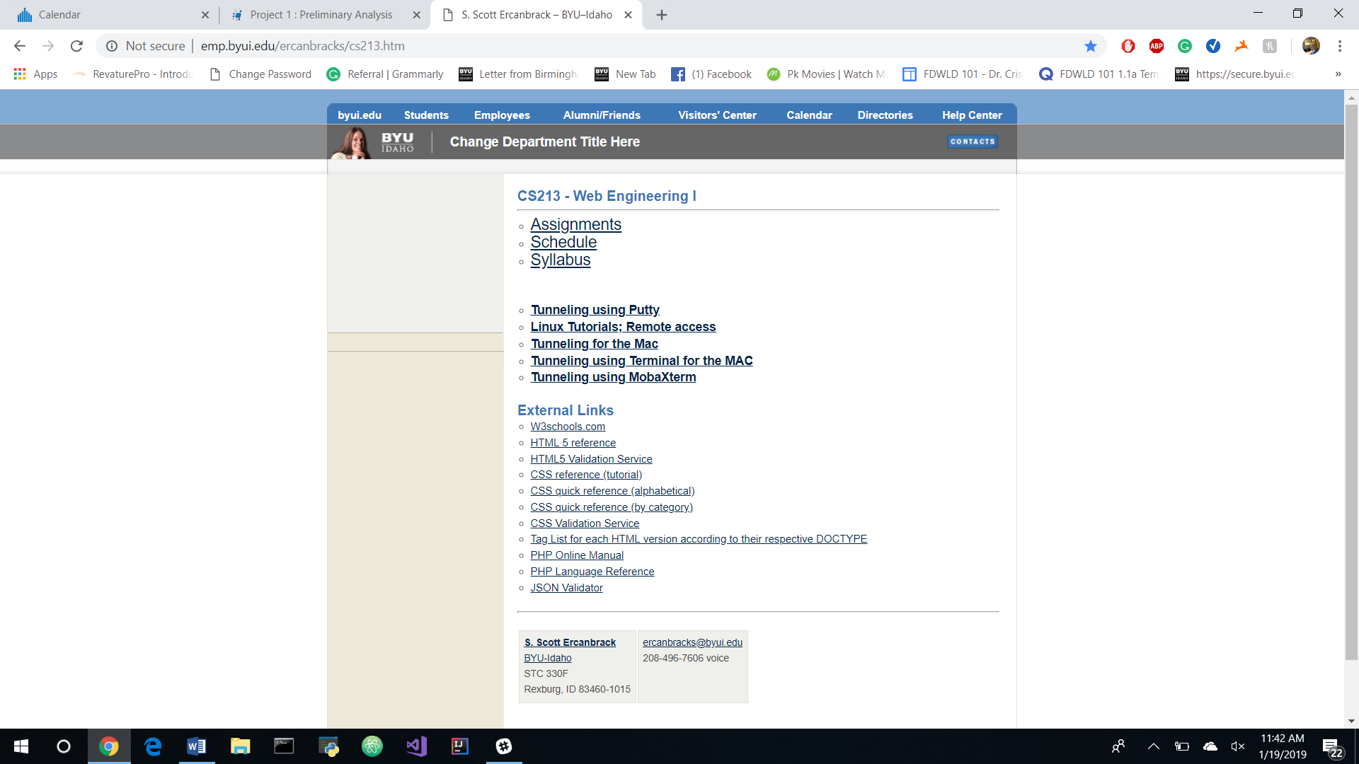

(For making the project more effective I showed this website to my friend and asked him to analyze the website without telling him anything.)

1. Interaction Framework:

Gulf of Evaluation:

1. Presentation: The presentation of this system is quite good. It functions very smooth and there are no bugs on the website. All the links are categorized in a different group so the user can guess and click on different links as needed. Except the heading of the web page, everything was making sense. Also, there is little lacking in information. It lacks the introduction and the intention of the web page.
2. Perception: The website was clear. The user or my friend was able to see all the information posted on a website. The use of blank space was very efficiently done. Because of having less information on the web page user was able to perceive everything.
3. Interpretation: I found this kind of the website is hard to understand by a normal user or even the student from a different department. The user went little off in this part of the evaluation process. But after taking some time to analyze a page, the user was back on his track.
4. Evaluation: The main confusion was to differentiate if the web page is a personal web page or school web page. The same problem happened even with me before in the first week of the class. The layout of the website looks like a university page. Also, it gives the option to change the name of the department. But everything on the page is personal or for one specific class. The breakdown that started from interpretation was going deep and wide in this section of the Gulf of evaluation.

Gulf of Execution:

1. Goal: The goal of the user is to learn the basic of the web. The user is ambitious and dedicated to learning at least some basic things that make web function. So, this part of the interface does not have any problem.
2. Intention: There is no problem in this stage. The user is using the correct things or tools to learn or fulfill his goal. The user can understand the tools. The user is sure that he can progress in web engineering if he follows the instruction given on the web page. The interface does not clarify how much it can do, but after looking through some links and reading syllabus the intention failure stops.
3. Specify Sequence: In this part, the user was having a problem in focus on the pattern of learning. There was not enough trust between the user and interface. The designer had failed to put things in order and in a sequence, so a new user couldn’t understand. The designer had focused much on giving schedule and syllabus, and helping to set up the environment for learning web, but the designer had failed to focus on pointing web link that is important in the learning process. Due to lack of help from the designer user struggles from maintaining sequence. This variable is the source of the Gulf of execution.
4. Execute sequence: Even though this variable is highly dependent on a specific sequence, the user was able to execute his goal after some unsuccessful attempt. Because of the user limited knowledge of the interface, the execution of the problem showed up. The accuracy was low, but there was constant motivation from sites like w3school where the user was successful. Some time flexibility; and the user was even able to change his specify sequence and make execute sequence successful. But, in general with a comparison to the time user took, I would say it was a failure.

Variable of Usability.

1. Efficiency: The interface was quite efficient. The web page was very responsive and accurate. It was direct and the user was getting the result what he expected from the link in the interface of the webpage. I will rate the interface 2 in this category.
2. Learnability: The learnability curve was pretty much like a broad parabola. The user was getting advanced and learning with the different task given in the site. I will rate this part of a variable to be 2 because I felt like user had to put a lot of effort and be self-motivated to become an expert from a novice but the part was continuous.
3. Familiarity: This part of the variable of usability was struggling to satisfy the user needs. The interface was quite consistent, but it was not compatible with other learning website or any other app. Maybe, it was not according to the user expectation where user thought about an objective type of question instead of writing real code. It was clear to the user that webpage was there to help students as a guide, but not to teach them on doing a web programming. I would give 1 to this variable of usability because I felt like the web page was designed for student and it familiar for a student in CS but for a new user.
4. Simple: The web page was simple. After maybe 5 minutes of using the website, the user was able to use the system. The user didn’t need to know a lot about the website to generate the first web page of his life. I would give 2 in this variable.
5. Mapping: As said in the previous variable the interface fails to map to the user mental model. The mapping was functioning accurately to the student in the class but people outside the class struggled to understand the web page. The web pages lack Direct Education as well as Deductive reasoning. There is an overuse of blank space and very less information. I would give 0 in this segment as mapping depends on the audience. Even the users of CS department will expect the website of web-engineering to have more function than just a box. But, it was a great surprise that the webpage was too simple.
6. Motivation: The interface lacked in this segment of the variable of usability. The interface is itself very simple that makes people confuse if the designer who is trying to teach is itself qualified or not. I would give -1 in the motivation because there is other apps in the market like w3school which is very rewarding and aesthetics for the code user does. This webpage/website requires self-motivation.
7. Trust: Trust was lacking between the user and interface. There was no continuous support and feedback from the interface. The user was unknown if the things he is doing is in the right order or not. The lack of trust also led to poor motivation, but it didn’t hurt the efficiency because most of the information on the site comes from the outside source. The user felt like the web page is trying to control him(which is one of the processes of learning/ most student know it). So I will grade it as -1.
8. Visibility: It was like a situation of don’t show everything and the stuff get lost. The webpage is not telling everything that new user needs to know. The web page lacks its introduction. How would a new user know the intention of creating a web page. I would score -1 for this case because the data or functionality required to complete a scenario can be found by the target user after significant searching.

(By the end of more than one hour of interaction with the new user, I realized that website has lacked a lot of weak points for attracting a user. I have decided to create a similar website during this semester where I will make changes in design to make it more suitable for any user)

### GRADING

|  |  |  |  |  |  |
| --- | --- | --- | --- | --- | --- |
|  | Exceptional 100% | Good 90% | Acceptable 70% | Developing 50% | Missing 0% |
| Selection Criteria 20% | It is clear the interface is important to the user and the user could benefit from a better design | All the components are present and the project is doable | All the components (user, interface description, and picture) are present but the project might be very difficult to complete | Example missing description of the user, description of the interface, or a picture of the interface | No item selected |
| Interaction Framework: Correctness 10% | It is "abundantly clear" that the interaction framework is fully understood | No errors in the listing nor defining the steps | One component of the interaction framework is incorrectly defined | Two components of the interaction framework are incorrectly defined | Three or more components of the interaction framework are incorrectly defined |
| Interaction Framework: Evaluation 20% | The interaction framework was used to correctly identify the core of the usability problem for the example | No mistakes were made in evaluating the example using the interaction framework | Analysis according to the interaction framework was inaccurate in one way | Analysis according to the interaction framework was inaccurate in two or more ways | The interface was not evaluated according to the interaction framework |
| Variables of Usability: Correctness 20% | It is "abundantly clear" that the variables of usability are fully understood | No errors in the listing or defining the variables | One variable is incorrectly defined | Two variables are incorrectly defined | Three or more variables are incorrectly defined |
| Variables of Usability: Evaluation 30% | The variables of usability were used to correctly identify the core of the usability problem for the example | No mistakes were made in evaluating the example using the variables of usability | Analysis according to the variables of usability was inaccurate in one way | Analysis according to the variables of usability was inaccurate in two or more ways | The interface was not evaluated according to the variables of usability |

**Grading:** Of course, the project is doable as well as if my website has links to other websites like w3school, Cybrary, or video of myself explaining things a lot of people can learn at least a basis of the web. I have spent more time than usually required by 3 credit online class. I have used my friend time and mine to evaluate things. Personally, with the effort, I have kept on it I am eligible for 100%.

I have some points to defend:

I have looked to the user’s behavior and tried to relate each behavior with interaction and usability points given in the book. So, there is at least an example for each point. And I am confident that the examples are in the right variable as needed. There is some exception sometimes because one variable effect another and they are linked. But I studied deeply in each of the topics to write my paper on this. I could easily evaluate myself to 100% if this was a math class or programming class. But since this is writing and analyzing, I would deduct my points in Grammar because I know my weak points.